1. **Age-it project: report of the status**

According to the aim of **Age-it**, a thermodynamic model of the human body has been developed, first in Engineering Equation Solver (**EES**) environment, and then in **Python**. Such a physical-based model is grounded on the assumption, commonly used in literature, that the human body can be considered as **multiple cylinders** **connected** as schematically represented in Figure 1.

*Figure 1: scheme of the human body.*

The conductive heat exchange transfer from the inner (“**core temperature**”, ) to the outer (“**skin temperature**” ) part of the cylinder is expressed by eq (1), which is valid for a cylinder with internal heat generation:

(1)

Where is cylinder radius and is the conductivity, and is the **metabolism**, namely the **internal heat generated** by biochemical route to keep constant the core temperature of the body and to supply energy for the motion. In case the body is not moving, the metabolism is called **basal metabolism** and it equivales to the minimum energy that is necessary to keep the internal temperature under control (around 37°C). In the current version of the model, the **basal** metabolism is expressed as function of the geometric characteristics of the body (height and mass), age, and gender. Moreover, the body releases energy to the environment by **convective** () and **radiative** () way.

Also, human body exchanges energy with the environment with breathing (). Breathing is necessary to get the oxygen needed for **metabolism**. **Accordingly, the following correlation (2), proposed by ASHRAE, evaluates as function of the metabolism.** Air enters the head, and it flows to the trunk, where oxygen is transferred to the blood. Therefore, the energy exchanged with breathing only regards certain cylinders: the head and the trunk.

(2)

Where is the vapour saturation pressure at ambient conditions.

Concerning the blood flow, **arterial** blood flows from a central reservoir (trunk) to **peripheral** parts (head, feet, hands); **venous** blood instead flows through in the opposite direction. Therefore, the thermodynamic effect of blood is to **warm** **the tissues;** accordingly, for each cylinder, we evaluate the **difference between the enthalpies of input arterial blood and of the output venous blood** () with the following equation (3):

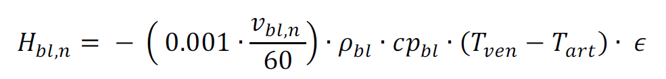 (3)

Where is the volumetric flow rate of blood (currently a fixed value), is the density of blood is the specific heat, is the difference between arterial and venous blood temperature. On the other hand, is a parameter that expresses the percentage of energy transferred to tissues compared to the maximum and it depends on the **heat exchange surface** and the **heat transfer efficiency**. In our calculation, is assumed to be equal to the internal temperature of the cylinder while is the temperature of the previous cylinder according to the flow of blood. The human body has the possibility to enlarge (**vasodilatation**) or to restrict (**vasoconstriction**) the cross-section of veins and arteries to regulate the heat exchanges between blood and tissues, with the objective to keep the core temperature around 37°C. This mechanism is called thermoregulation system. For example, in cold environments, vasoconstriction allows to reduce the heat exchange surface and limit the dispersions; the opposite mechanism occurs in hot environments, in which the human body aims to increase the dispersions. **The variations of heat exchanges surfaces (vasoconstriction and vasodilatation) result in variations of the parameter .** Indeed, the model returns values as function of the external temperature (Figure 2). **N.B. The model developed on EES precisely calculates , whereas the python code may present numerical problems in evaluation.**

*Figure 2: calculation of the parameter* *as function of the ambient temperature.*

**At the status of the model, a direct correlation between the blood flow rate () and the metabolism () is not implemented. Nevertheless, this issue will be addressed in the future because, since the actual function of blood is providing oxygen needed by body tissues for metabolism, there is a close correlation between these two variables**. **On its turn, the blood mass flow rate is in principle related to the heart rate.**

Another heat transfer flow from the human body to the environment is due to the evaporation of sweat: part of the heat produced by human body is dissipated for the **evaporation** () of **sweat drops onto the skin**. To estimate this contribution, we consider a “**skin wittedness**” variable calculated using correlation (4) and is calculated as (5):

(4)

(5)

In case the body is in motion, the cylinder performs a work () that should be considered when modelling the thermodynamics of cylinders. At the status, the model allows to consider external work by arbitrarily incrementing the metabolism. However, depending on the performance and training level, each person may have a different response in terms of metabolism.



*Figure 3: Scheme of the model.*

According to the above description, the goal of the thermoregulation system is to minimize the increase of the core temperature, and thus of the **internal energy** of the body (), resulting from the overall energy balance of the body (Figure 3). The thermoregulatory system is modelled as an optimization model that minimizes to zero the overall increase of the internal energy of the body (more details in Section 2).

In our model, the body is composed of the following cylindrical parts:

* Arm
* Foot
* Forearm
* Hand
* Head
* Leg
* Neck
* Thigh
* Trunk

The current version of the code also contains the exergy model of the human body grounding on the same approach as described in previous paragraphs.

1. **Structure of the model**

The most updated version of the model is developed in Python; the script is shared on Github and it is structured in different levels:

1. The first level of the model is the “*constant.py*” file, in which we set the constants of the model (i.e. fluids thermos-physical properties).
2. The second level the “*cylinder_model.py*”; the cylinder is modelled as a class, which means that given the geometric properties of the cylinder (i.e. length or radius), the model returns the heat exchange surfaces and the heat transfer flows. Indeed, “*cylinder_model.py*” recalls the “*constant.py*” to retrieve the thermo-physical properties of fluids to implement the heat transfer equations valid for all cylinders.
3. The third level of the model are the subclasses (located in the subfolder “subclasses”) that recalls “*cylinder_model.py*” and sets the geometrical properties of cylinders. For example, the files “*arm.py*”, “*foot.py*” … are the subclasses.
4. The fourth level of the model is the “*body_model.py*”, that recalls all subclasses and performs the overall energy and exergy balance of the human body. This file also contains the optimization algorithm for the increase of internal energy minimization.
5. The fifth level is the “*Initial Calculation.py*” that allows to run the calculations, also deciding which variable should be the inputs and the outputs.

Figure 4 represents the structure of the model that is available in Git-hub, that have been extensively commented. The number of variables that can be calculated are equal to the number of cylinders. For example, the model can be used to assess, given and the metabolism, the values of core temperature inside cylinders. On the other hand, it would be possible to set one of the temperatures (i.e. the core temperature of the trunk) to evaluate and the other temperatures of the body**. More in general, we can play with the model to evaluate a number of variables equal to the number of cylinders (e.g. evaporation, metabolism), and by setting the other variables to known values (eventually measured experimentally).**



*Figure 4: representation of the model.*

1. **Limitations and potential upgrades**

The model currently presents several limitations; among them, considering the aim of Age-it project, it is necessary to remark that t**he model does not consider the effects of ageing and cardiovascular issues in elderly people**: with ageing, the capacity of the thermoregulatory system changes, thus determining potential increases or decreases of the internal temperature. For example, the capacity of vasoconstriction and dilatation, expressed by **,** can be different in old people than in young ones.

In addition, the current version of the model also presents following limitations (sorted by priority):

1. **The model does not consider “time” as a variable**: the thermodynamic behaviour should be evaluated dynamically in non-steady-state conditions.
2. **The model does not consider motion and exercises:** in case the body is in motion, the work the body () is not zero. To generate work, the human body must increase metabolism; to increase metabolism, the human body has to increase the oxygen/blood mass flow rate; to increase the oxygen/blood flow rate, the human body has to increase the heart rate, the breathing, and the arteries/veins have to increase their cross section to prevent the increase of pressure (vasodilatation). To keep the temperature under control, that would be incremented by metabolism and blood flow rate, the body starts sweating and dissipating heat with sweat evaporation.
3. **The model is valid for naked body, and clothes are not accounted**: clothes represent an additional layer and thus a conductive heat transfer resistance that depends on the material of clothing. In addition, there is an air layer between the skin and the clothes. In case movement is considered, such air gap has a variable thickness.
4. **The model considers body parts as single cylinders without evaluating its multiple layers (i.e. muscles, fat) and different shapes than regular cylinders**: certain parts of the body are more similar to a sphere (i.e. head) or tapered cylinders (i.e. foot) rather than standard cylinders. In addition, cylinders should be composed of several layers (i.e. bones, veins, muscles, fat, skin) with different thermal properties.
5. **Some more specific model for certain parts of the body** (i.e. head, trunk, hands, foot) could be considered. I.e., gloves
6. **The model does not include differences between males and females thermal behaviour, excluding the different metabolism expressed with empirical correlations.**
7. **The exergy analysis should be improved, especially considering the effect of metabolism.**
8. **The model does not allow to consider wearable devices for the energy production.**

In addition to the above mentioned “modelling” limitations, sorted by priority, it is necessary to consider that **the model is not calibrated/validated with experimental data (see Section 5):** most of inputs are based on static assumptions available in literature; primary data would allow to obtain data that are valid for specific boundary conditions defined in the experimental setup.Given the above-mentioned limitations, we developed a literature analysis of studies, classified based on the research topic.

1. **Literature review**

The review is summarized in an excel file table, attached to this report, that easily allows to identify for which type of research gap each study could provide useful information. Firstly, the literature review has been conducted on “Scopus” with keywords “**thermal model AND human body**”. This research brought to identify 49 papers related to this topic only in 2022-2023. Therefore, an additional filter “**thermal model AND human body AND elderly**” has been added and 13 studies have been found regarding this topic. The literature review results are summarized in an excel file that allows to filter the papers depending on the scope (experimental, modelling, review) and the research focus (e.g. metabolism, age, clothes, motion…). In this way, when the current version of the model will be further developed by filling one of the above-listed limitations, it will be possible to easily identify those paper that could provide useful data, correlations, methodological approaches, or other information.

Figure 5a shows that most of the studies (56%) are experimental studies aiming to the measuring of physiological parameters expressing the behaviour of thermoregulatory systems. These studies are based on experimental tests on heterogeneous human samples in terms of age, gender, fitness level. A major attention is also given to the analysis of the environmental boundary conditions during different levels of exercise stress. These studies represent a solid ground to define experimental setups because they explain which thermophysical indicators should be considered and how measures can be conducted. Concerning the studies related to the development of thermodynamic models of human body, they represent around 34% of the total. These studies are particularly useful to integrate the current model with additional features and address the limitations outlined in the previous section. In addition, it is necessary to underline those studies (10 papers, around 20% of the total) that couple experimental and modelling enalyses to create, calibrate and validate the model developed by the authors. Six studies (around 10%) are literature reviews that could be extremely helpful to summarize the state of the art focused on both experimental studies and to extend the current literature overview and to papers that have been published before 2022.

Figure 5b represents the classification of all studies identified in the literature review classified by research focus. Remarkably, most of the studies address with particular interest the thermodynamic model of clothes (17%), the development of multiple-layers cylinder models (17%) and the thermodynamic analysis of specific part of the body that could be exposed to particular conditions (17%); for example, a detailed modelling of head helmets during cycling or the effect of gloves on people hand. Some studies specifically address, using a computational or experimental approach, the thermodynamic effects of physical exercise (13%), of age (10%) and of different thermal conditions in buildings. On the other hand, some papers do not address any specific issue among the above-mentioned ones. However, also these papers should be undervalued because, although not very specific, they provide useful insights about multiple aspects of the problem (which as the evaluation of environmental boundary conditions). This classification represents a strong basis for the implementation of the model thus addressing all its limitations.



*Figure 5: Literature review results*

The above-mentioned papers are published in Journals that belong to different scientific fields due to the high interdisciplinary level of the study. Journals are classified into 4 categories that related to different scientific field.

*Table 1: Journal clustering.*

|  |  |  |  |
| --- | --- | --- | --- |
| **Biomedical**  **engineering** | **Energy**  **Engineering** | **Energy and buildings** | **Other engineering**  **fields** |
| American Journal of Physiology | Applied Energy | Building and Environment | Chemical Engineering Journal |
| Computers in Biology and Medicine | Energies | Energy and Buildings | IEEE Journal Of Biomedical And Health Informatics |
| International Journal of Biometeorology | Energy | Indoor Air | Journal of Biomechanical Engineering |
| International Journal of Environmental Research and Public Health | Energy Conversion and Management | Indoor and Built Environment | Materials |
| Journal of Physiological Anthropology | Heat and Mass Transfer |  |  |
| Journal of Thermal Biology | International Journal of Thermal Sciences |  |  |
| PLOS ONE | Journal of Energy Storage |  |  |
| Sports Medicine | Renewable and Sustainable Energy Reviews |  |  |

Figure 6 demonstrates that most of publications are available in journals in the biomedical field (30), particularly in *Journal of Thermal Biology* (15). Energy and building also represents an important cluster of publications because 13 papers can be associated with that research field, especially *Building and environment*. Energy engineering publications, namely those Journals that address energy research in a broader way, can count 10 publications. In addition, there are a few Journals that, although not belonging to none of the above-mentioned categories, contain valuable studies regarding the energy modelling and experimental analysis of human body thermodynamics. Over the above considerations, it is possible to observe that while it the papers published in international Journals are mostly experimental-oriented (although containing extremely solid experimentally validated mathematical models), the papers published in Engineering present a more evident equilibrium between modelling and experimental analyses. On the other hand, when we focus on those papers related to ageing, these studies are published on biomedical journals (9) and in Energy and Buildings group (4) and regard both modelling and experiments.

Most present authors:

* Ying Lei
* Faming Wang
* Carlos Eduardo
* Keutenedjian Mady

Most present institutions:

* College of Safety Science and Engineering, Xi’an University of Science and Technology, Xi’an 710054, China
* Division animal and human health engineering, department of biosystems, KU Leuven, Leuven, Blelgium
* Department of Mechanical Engineering, Centro Universit´ario da FEI, 09850-901, S˜ao Bernardo Do Campo, Brazil

*Figure 6: number of publications by journal.*

1. **Experimental setup**

The literature analysis presented in the former section demonstrates that both experimental analyses and modelling are fundamental to clearly represent the thermodynamic behaviour of human body. Experiments allow to get useful data to calibrate the model inputs and parameters and to validate the results. Indeed, among the papers analysed in the literature review, several encompass both the experimental setup and the mathematical modelling.

First, experimental data may be used to validate the results obtained by the mathematical model. For example, the skin and the core temperature measured with specific instruments may be used to validate the results of the model; in addition, depending on the mismatch between the results obtained by the model and the outputs of the experiments, operating parameters of human body thermodynamics may be calibrated to minimize this gap.

Interestingly, experimental data analysis may lead to create highly specific correlations to express phenomena not directly related to thermodynamics. For instance, metabolism is a biochemical process that is partially related to thermodynamics. For example, it may be possible to evaluate a correlation between the blood mass flow rate and the metabolism during exercise by measuring the heart rate and the breathing intensity. Once the mass flow rate is assessed, blood pressure could be used to assess the cross-section of veins and arteries and include this value in heat transfer equations. In addition, the increase of metabolism implies the need to dissipate some exceeding energy from certain parts of the body through the evaporation of sweat. Accordingly, measuring variations in indoor air humidity could be recommended to estimate evaporation energy losses.

The literature review excel file allows, for each research topic, to identify the most recent and valuable papers that could contain existing correlations that may be evaluated, or reference measurements to check the reliability of experimental test by comparative way.

The modelling equations are represented in Section 1 of this report. On the other hand, experimental tests have not been carried out so far. One of the goals of the proposed literature review is to point out which parameters should be measured to improve our model towards the research directions defined in Section 2 of this report. Among all the papers selected in the literature review, (Lei et al., 2023) propose a very important review aiming to the standardisation of experiments (Figure 7).

*Figure 7: paper from Lei et al. 2023*

First of all, (Lei et al., 2023) makes a strong distinction between outdoor and indoor tests: in the former, environmental conditions depend on the weather and they are not under control and they are approximately constants during the tests; in the latter, environmental conditions (i.e. temperature, humidity …) can be controlled with HVAC systems and they can vary during due to the test, especially when physical exercise is involved.

More specifically, the key messages provided by (Lei et al., 2023) research study are the following:

* **Skin temperature is the most common physiological variable to include in indoor thermal comfort/discomfort studies**. Typically, skin temperature is measured at **various anatomical sites** to obtain the mean skin temperature using various weighting ratios. Skin temperature is often measured by **skin thermistors** (e.g., YSI thermistors, YSI Incorporated, Yellow Spring, OH, USA) **connected to the** **data loggers** or **tiny wireless temperature loggers such as iButtons** (Maxim Integrated, San Jose, CA, USA) and SmartButton (ACR Systems Inc., Surrey, BC, Canada). Despite wireless temperature loggers offer more degrees of freedom than skin thermistors, their measurement ac- curacy is **quite low, i.e., 0.5 ◦C**. Skin temperature sensors with an accuracy of **±0.1 ◦C** are highly recommended for human trial studies including indoor thermal comfort research. **Individual calibration regression could be used to improve the accuracy of tiny wireless temperature loggers like iButtons to about ±0.1 ◦C.** Nonetheless, such calibration methods are not always available, and it is complicated because the calibration necessitates high demands on specifications of the calibration bath as well as reference thermometer.
* **Core temperature is often being neglected** in the indoor environment because the duration of the exposure may not result in a great elevation or decline in core temperature. Due to this reason, most of the indoor thermal comfort studies do not include core temperature measurements. Core temperature measurements are highly **recommended** when using participants who are **not thermoneutral** while entering an indoor environment or working in non-air- conditioned indoor conditions with **highly fluctuating temperatures for long hours** (e.g., **4–8 h**). In thermophysiology related experiments, the golden standard for core temperature measurement is to insert an esophageal temperature probe to the esophagus of the participants to the distance of the quarter of participants’ standing height. However, as this procedure is highly invasive and would certainly result in an unpleasant feeling, it is not recommended. On the other hand, the rectal temperature probe is recommended as it can obtain reasonable accuracy when compared to the esophageal probe. Furthermore, it is less expensive than the gastro-intestinal tract temperature capsule and has been adopted in thermal comfort studies. **However, other studies also indicate the possibility to ingest a pill that measures the core temperature and transmits it to a data logger.**
* When investigating thermal comfort with a special population such as **cardiovascular disease patients** or the older adults, **blood pressure** **and heart rate measurements** are **recommended** as those measurements could serve as the termination criteria for those populations. Specifically, it is well known that the **elderly or the cardiovascular disease populations have a higher level of cardiovascular strain** during heat or cold exposure, so including those measurements in these populations can greatly prevent the adverse events during the data collection period. The typical termination criteria for those populations is the gradually reduction of systolic blood pressure with an elevated heart rate over three consecutive measurement period. **The heart rate and blood pressure measurements can be conveniently obtained using the conventionally heart rate monitor and sphygmomanometer.**

The most common perceptual response measures in indoor thermal comfort studies are **thermal sensation votes** and **thermal comfort/ discomfort votes**. Thermal sensation vote is our discriminative perception, which is defined as the relative intensity being sensed from the environment and it is mainly regulated by skin temperature. On the contrary, thermal comfort is our affective perception, which refers to the subjective indifferent to the surrounding environment. Thermal comfort is regulated by the deviation of both **skin** and **core temperatures** and this is another reason why including core temperature measurement when assessing thermal comfort is recommended because it can ensure that the subjects are not in hyperthermic or hypothermic state. It is worth mentioning that thermal comfort vote directly dictates our behavioural response in any given environment; therefore, measurements of both thermal sensation votes and thermal comfort votes are deemed necessary when conducting any indoor thermal comfort related experiment. For example, the **ASHRAE 7-point scale for thermal sensation** (“cold” (-3) to “neutral” (0), to “hot” (+3) and thermal comfort/discomfort scale (“very uncomfort- able” (−3), to “neutral” (0) and to “very comfortable” (+3)) are different from the Gagge et al.’s 7-point scale for sensation (cold (1), to cool (2) to neutral (4) and to hot (7)) and 4 points scale for thermal comfort (comfortable (+1), to slightly uncomfortable (+2), to very uncomfort- able (+4))

**Both aerobic fitness and percent of body fat can independently alter thermal perceptions**, it is necessary to measure those variables to serve as the inclusion and exclusion criteria of the studies relating to thermal comfort in an indoor environment. **The measurement of physical activity/aerobic fitness can be measured by conducting a VO2max test or by completing a physical activity questionnaire**. Measurement of VO2max may be inappropriate in indoor thermal comfort studies as this requires a **metabolic cart** to obtain the accurate value of **maximal oxygen uptake**. However, using a physical activity questionnaire to assess physical activity level could be the alternative approach to ensuring participants have comparable aerobic fitness. The measurement of percent body fat can be easily done using bioelectrical impedance or by using the skin fold caliper at three anatomical sites (i.e., abdominal, triceps and suprailiac). However, the skin fold measurement is not recommended if the experimenters have no prior experience with the skin fold caliper because the results are entirely dependent on experience.

The total duration of a **human trial experiment is an unavoidable design factor** that should be considered when designing indoor thermal comfort studies. **The experimental duration should be determined based on the study objectives and categorized into three different types (short, moderate and day-long exposures).** **For normal indoor thermal comfort studies** to assess indoor thermal environments or the per- formance of personal comfort systems, **the standard exposure time duration is 1.5–2 h (short)**. If the study is intended to assess work or learning performance, the recommended exposure duration should be increased to 3.5–5.5 h or 8 h (moderate)separated by 1–2 breaks to simulate real-world office work scenarios. In recent decades, extreme heatwaves become more intense and more frequent. Many European and American residential homes lack air-conditioning, indoor temperatures during extreme heatwaves could exceed 35 ◦C for several hours to **10 h**. For vulnerable groups such as older adults and patients with chronic diseases, environmental demands exceed physiological capacity during extreme heatwaves. If the goal of the study is to examine the impact of a heatwave on indoor occupants, daylong acute indoor exposure studies may be designed. Furthermore, chronic intermittent indoor heat exposure studies may be designed to investigate the actual impact of prolonged heatwaves on indoor occupant health. Many key physiological parameters, such as core temperature, heart rate, blood pressure, sweating rate, skin blood flow, and blood-based (or serum-based, urine-based) biomarkers to quantify cell dysfunction, degradation, or inflammation, should be collected and analysed for the aforementioned extreme indoor studies. Nonetheless, many parameters, such as blood pressure, skin blood flow, and sweating rate, may only be displayed or measured in an hourly basis.

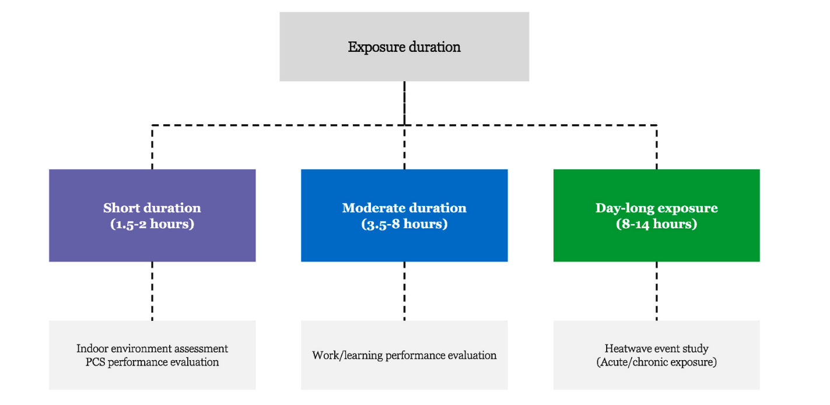

*Figure 8: Scheme of experiments durations recommended by Lei et al.*

In addition to the review published by (Lei et al., 2023), several studies create specific tables to describe the equipment used in their test case. The following of this report contains some examples.



*Figure 9: experimental setup of (Luo et al., 2023).*

* Measuring core temperature; from (Luo et al., 2023)*:* a pill can be ingested, measure the core temperature from the throat the the liver, and return data to a momnitor (it includes 10 pills). **2000 $**

[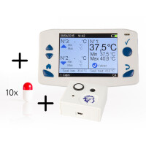](https://www.mindtecstore.com/BodyCap-eCelsius-Performance-Starter-Kit)

* Measuring skin temperature from (Luo et al., 2023). See technical details about the use (van Marken Lichtenbelt et al., 2006). **100 $**

* Infrared temperature from (Luo et al., 2023), **3000€**
* Heart rate FitBit Inspire 2: **100€**

[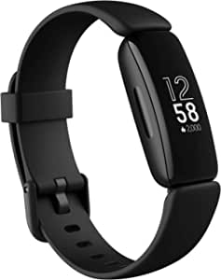](https://www.amazon.it/Fitbit-Inspire-Benessere-Gratuita-Rilevazione/dp/B08DFGPTSK/ref=sr_1_2?adgrpid=103904269094&hvadid=591603580018&hvdev=c&hvlocphy=1008311&hvnetw=g&hvqmt=e&hvrand=17568555046268601522&hvtargid=kwd-742820043536&hydadcr=17013_2168186&keywords=fitbit+inspire+2&qid=1685381562&sr=8-2)

* Thermal comfort station: **100 €**

[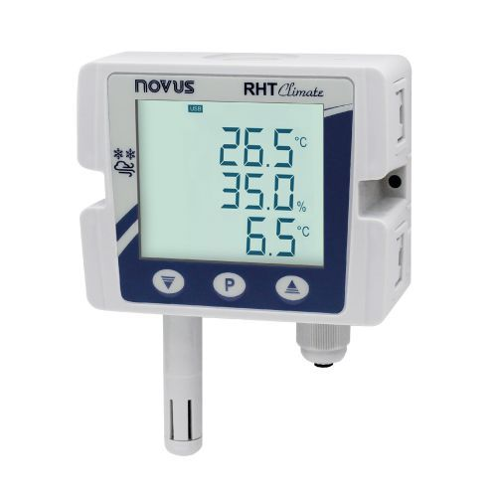](https://www.itsensor.it/trasmettitori-di-temperatura-e-umidita-ambiente-modbus-cod-rht-climate-wm-485.html?gclid=Cj0KCQjwmtGjBhDhARIsAEqfDEf5RIbWOyS3MD3vNgWHE9iCHF0-bgZZGBkMoOAKVqZsCnS4DmqxjuQaAh4NEALw_wcB)

* Tapis roulant, **4000 €**